Technical Analysis

1. Understand & comment on the past performances of each stock in your portfolio.

**Portfolio Daily Returns**

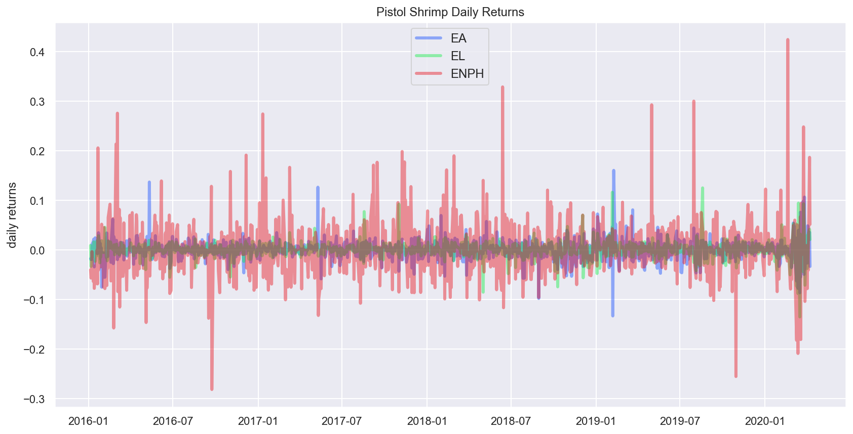

**Overall Trends**

To see how our stocks have performed relative to the overall market and to perhaps help understand trends, we plotted the ETF ‘IVV’, which follows the S&P 500.

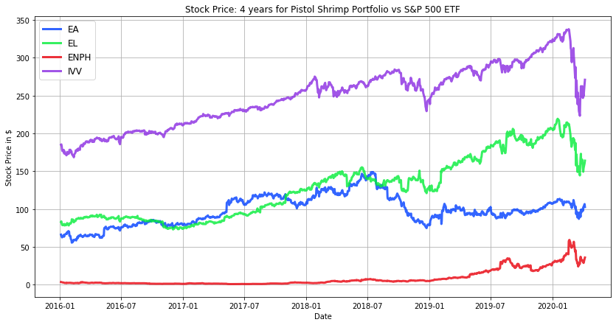

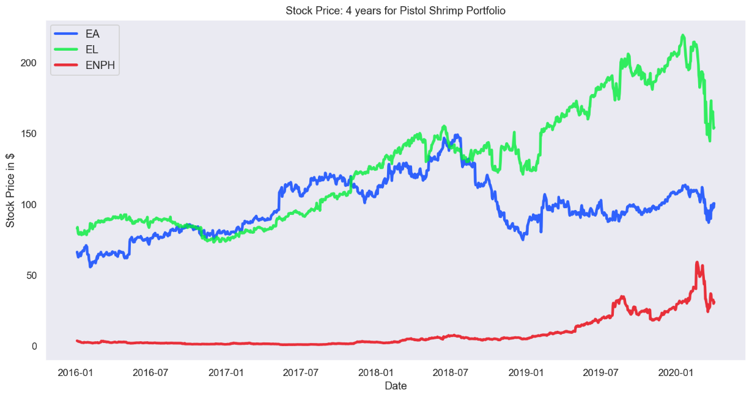

**Group Performance – Relative to S&P 500**

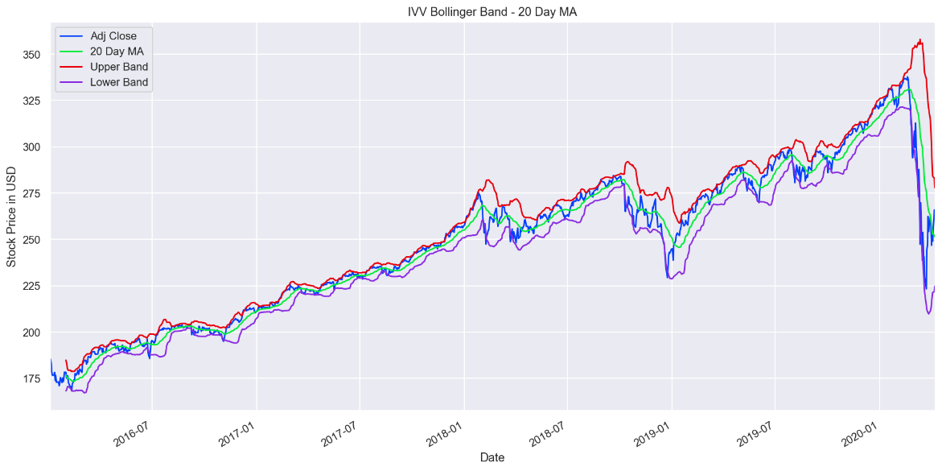

* EL and EA experience a similar drop in stock price around the same time in Feb 2018. This month was one of Wall Street's wildest months since 2008 (though of course, prior to CovidCrash). Amidst the Eurozone Debt Crisis in February of 2018, the Dow plummeted 12%, in just two weeks. Likely, this was due to the spiking bond rates that were pricing in the threat of inflation. Investors suddenly became worried that the Federal Reserve would raise interest rates because the recent massive tax cuts could overheat the already-flush economy. Also, the post-election surge had left stocks relatively expensive — and vulnerable to a sharp pullback.
* EL and EA all experience a similar drop in stock price around the same time in May 2018, alongside the Dow falling 1.58% amid political turmoil in Italy that sent the Euro tumbling and ongoing difficult trade talks with China.
* EL and EA experience a similar drop in stock price around the same time in December 2018. The Dow and S&P 500 recorded their worst December performance since 1931 and their biggest monthly loss since February 2009. During the month, investors dumped stocks amid concerns of an economic slowdown and fears that the federal reserve might be making a monetary policy mistake.
* The S&P 500 has a big dip from September through to January 2019. The latter quarter of 2018 was tumultuous for the stock market, the first time ever the S&P posted a decline after rising the first three quarters; in fact, relative to the previous 3 years, all of 2018 was quite volatile for the whole stock market, characterized by record highs and sharp reversals.
* Our portfolio of stocks took a big dip after oil crashed concurrently with Coronavirus hitting, around March 2020. EL seems to have taken the biggest dip. After bottoming out, they all tentatively seem to be starting to bounce back as of early April 2020.

**ENPH past performance**

ENPH: Enphase Energy Inc., Solar Microinverter Company, the world’s leading supplier of solar microinverters.

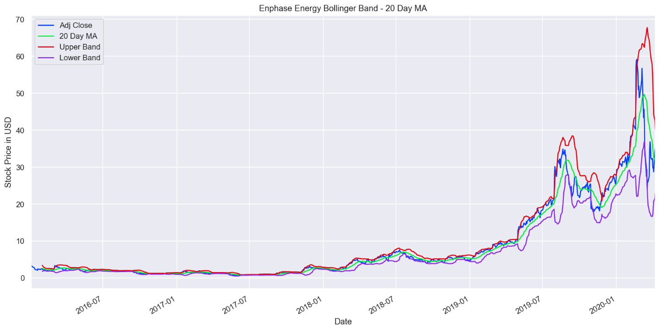

* Late 2016, ENPH introduced its new energy storage products to the market. Their systems are flexible and can pair with non-Enphase energy storage systems.
* Overall growth is a result of the increased demand for their innovation of solar microinverters and higher AC module shipments. AC modules are a unique blend of microinverter and photovoltaics that are time- and cost-efficient. Enphase invented the microinverters, which converts DC power captured in a panel from sunlight to AC power. Since the solar industry is expected to grow, there’s huge growth potential ahead for Enphase Energy—the key technology provider for panel makers.
* ENPH turned profitable in Q4 of 2018. Their new product lineup and latest-generation IQ 7 microinverters revolutionize the industry. They overcame an industry-wide component shortage of high-voltage transistors (due to increase in demand for electric vehicle charging equipment, which uses the same component) by signing new suppliers. The component undersupply had eaten into their revenues previously.
* For the first half of 2019, ENPH had massive operating performance, posting massive revenues and profits, with a sharp surge July-Aug 2019 (Q2 2019). They no longer face competition from Chinese Microinverter company Huawei; this was their 3rd straight profitable quarter. Their projections of net income in 2019 10x that of 2018. Q2 2019 operating results blew past expectations from analysts and even executives. The stock price climbed by more in a single day than it had been worth at the beginning of the year.
* Sharp drop Sept 2019, then again October. They had posted a 600% year-to-date gain before this plunge, was due for a correction.
* In May 2019, ENPH announces they will release in mid 2020 their next-gen microinverter, IQ8, a ‘grid-agnostic’ ensemble system. This tech will be the building block for their company’s larger product ecosystem.
* ENPH stock price plunged last quarter of 2019 since other alternative sources of energy like natural gases went down, leaving homeowners with cheaper alternative sources of energy.
* Steady increase Dec 2019, leading into a huge surge through Apr 2019. ENPH signs a strategic supply agreement with Sunrun Inc., the nation’s leading home solar, battery storage and energy services company, to bundle its IQ7 microinverter with Sunrun's residential solar solutions. ENPH microinverters account for 98% of all microinverters shipped.
* Over the past 3 years, EPH has experienced growth in revenue, profit, and operational cash flow, setting them apart from many renewable companies.
* After posting a 55% climb through Feb 2020, shares sank 34% in March, during which time the S&P 500 dropped 12.5% amidst the Coronavirus spread. Crucially, two locations particularly vulnerable to the virus’ spread are China and California. Enphase Energy’s microinverter factor is located in China; their HQ is located in California, a significant proportion of revenues are driven by the California’s residential solar market.
* April 2020, as the stock is starting to recover, ENPH announces they will strategically partner with Rexel expand their distribution network in Australia.

**EA past performance**

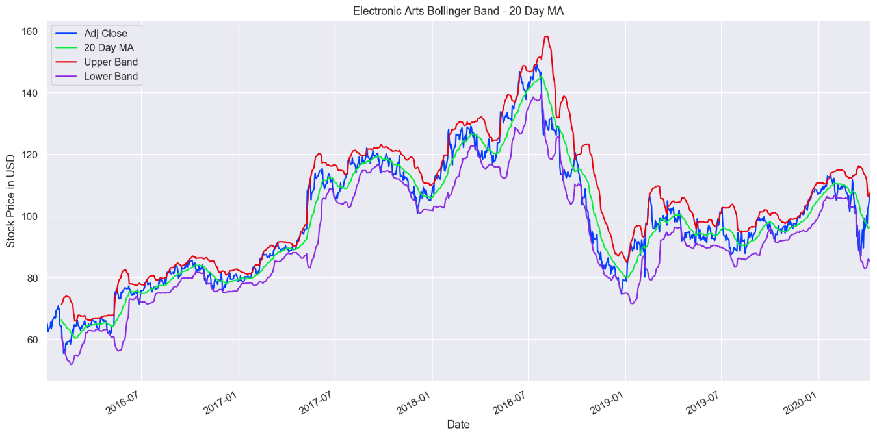

* From end of 2013 to July 2018, EA had great performance, seeing its with stock price climbing 461%.
* The first half of 2018 saw tremendous momentum for EA, with digital revenue surging 17% over the previous year, driven with strong customer engagement with their flagship sports products, *NFL 18* and *Madden NFL 18*.
* EA had a particularly volatile 3rd quarter of 2018, with a sudden, steep and sustained decline. First, in August, it announced the delay of its game *Battlefield V* until Nov 2018, meaning they would have to push some revenue from calendar 2018 into 2019. This announcement also affected its stock performance later and amidst a competitive market (ie *Fortnight*), lead to an underperforming quarter. Relative to S&P 500 index, which lost 6.35% in value over 2018, EA finished 2018 *down* almost 25%, after hitting an all-time high of $151.26 in summer 2018.
* EA experienced a plunge, falling 13.3% in a single day, and shaved more than $3.7 billion off EA’s market capitalization. *Battlefield V* ended up flopping, selling more than a million fewer copies than expected in the first quarter of 2018, so they missed their holiday sales target. EA CEO Andrew Wilson said that the company faced ‘significant challenges’ in their third quarter, and that that would continue through the fourth quarter. EA failed to gain momentum and failed to meet sales for the quarter ending, this drop in a competitive quarter led to underperformance and the stock price went down.
* September 2019’s *FIFA 2019* release was not a hit with consumers so did not generate the digital revenue they had expected.
* Oct 2019 EA stock dropped 4% after announcing it would cancel its basketball game for the year.
* In 2019, EA reported 3rd quarter net income of $262 million, relative to its 2018 3rd quarter *loss* of $186 million.

**EL past performance**

Sold in over 120 countries and territories, EL consists of a vast number of well-recognized brands.

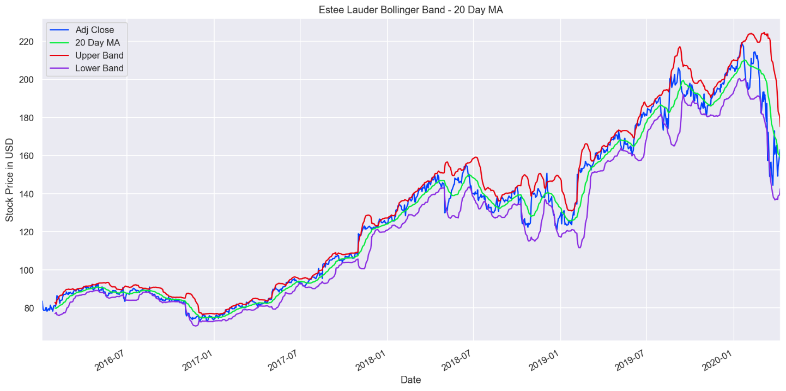

* After its 2014 acquisition of Le Labo and January 2015 acquisition of GLAMGLOW, EL continued its spree of acquiring small brands with global appeal in 2016, by integrating By Kilian, a high-end fragrance suite.
* EL generally posted a poor performance in 2016.
* EL expanded operating margins and beat analyst expectations for every quarter in 2017. In part, EL received good press by achieving a fundraising milestone in its Breast Cancer Campaign to fund research, education, and medical services. The last quarter had two catalysts for growth: appealing to millennials by hiring social-media-savvy celebrities like Kendall Jenner to promote their products and focussing on fast-growing markets (ie. China) – two groups whose purchasing power is only set to grow.
* The quarter ending December 2018 reported 17% increase in sales, due in part to the acquisition of 2 new brands Too Faced and Becca acquired in late 2016. This is part of their strategy to be savvy with acquisitions. Too Faced is a prestige cosmetics producer popular with millennials, and at $1.45B, this was the largest acquisition in EL’s already enormous portfolio.
* 2019 saw incredible growth for EL, with some initial volatility and a dip around August-Sept 2019, followed by another rise up until the CoronaCrash. The acquisition of Do the Right Thing and Jart+ have buoyed their position within the industry.
* EL performed well in 2019 despite tariffs imposed on China.
* Strong 2019 Q4 – up 55% since January -- are due in part to growth in Asia, the popularity of cosmetics in the heightened world of social media such as Instagram, and an ever-growing demand for skincare products.
* ##Covid

1. Understand & comment on the covariance and correlation between each stock in your portfolio.

**Covariance**

Used in Modern Portfolio Theory to determine which assets to include in our portfolio, covariance measures the directional relationship between two asset prices. The covariance matrix is used to calculate the standard deviation of a portfolio of stocks, which we will use to quantify the risk associated with our portfolio and will then help us construct the Efficient Frontier. A positive covariance means that assets generally move in the same direction, whereas negative covariance indicates stocks generally move in opposite directions.

In our portfolio mixture, our assets all have a negligible positive covariance.

There is very little covariance between the stocks in our portfolio.

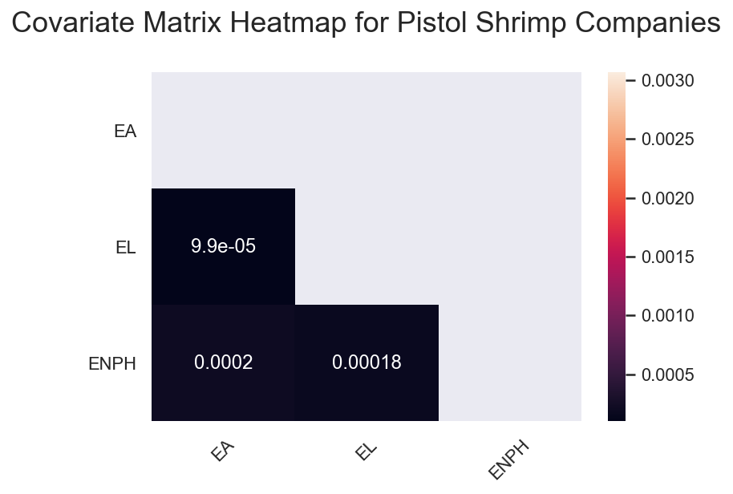

* EL and EA have the lowest covariance; EL and ENPH have the highest covariance.

Our goal is to select assets that have a lower standard deviation for the combined portfolio that is less than the standard deviation of the individual assets, thereby reducing volatility of the portfolio. MPT aims to create an optimal, diversified mix of higher-volatility assets (such as ENPH) with lower-volatility assets (such as EL). In doing so, we aim to reduce risk and still allow for a positive return.

**Correlation**

 While correlation coefficients lie between -1 and +1, covariance can take any value between -∞ and +∞. Covariance measures the direction of the linear relationship between variables, whereas correlation indicates both the strength and direction of the linear relationship between two variables.

All the stocks in our portfolio have a degree of positive correlation.

* EL and ENPH are strongly correlated, at 0.82. That is interesting given that they are entirely different industries, gaming and renewable energy.
* EL and EA are moderately correlated, at 0.39.
* ENPH and EA are very weakly correlated, at 0.096.

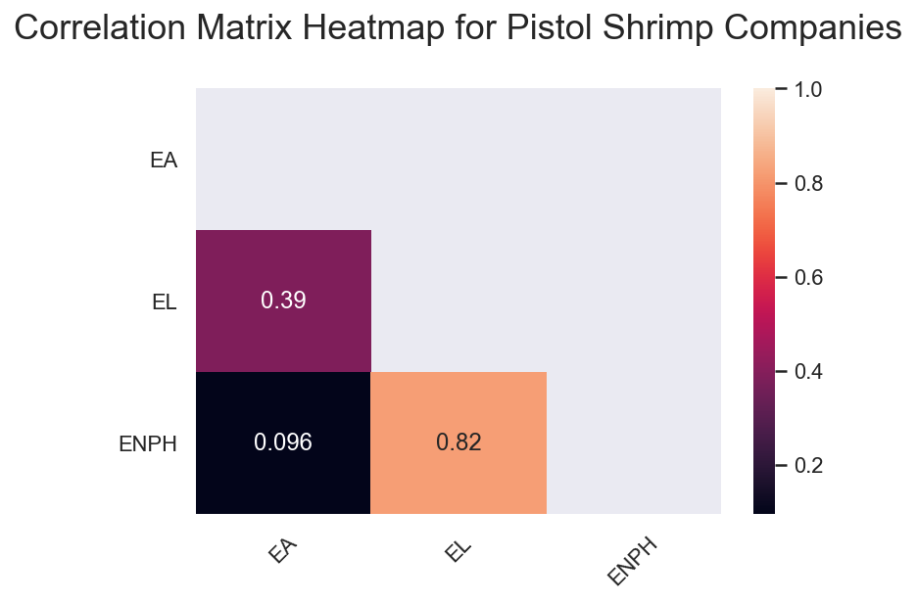

1. Perform price prediction using Monte Carlo analysis for each stock and comment on their outlook.

**Monte Carlo Simulation: Enphase Energy (ENPH)**

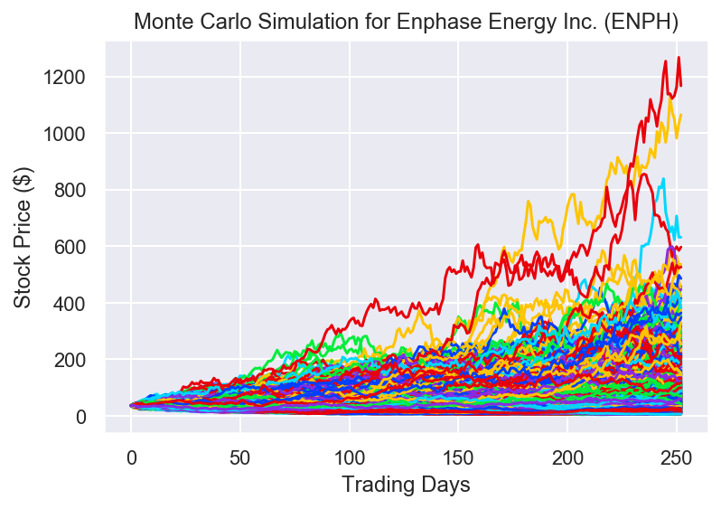

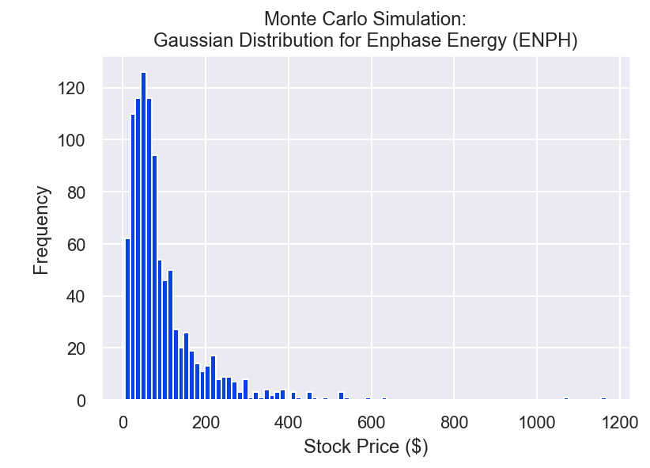

Mean ending value of the simulated 1-year ENPH stock price: $95.14

ENPH 95% confidence range: $89.06 - $101.21

Standard deviation: $97.84

The maximum yearly simulated ENPH return is $1167.12

The minimum yearly ENPH return is $4.69

5th percentile: $16.03

Median: $65.98

95th percentile: $264.11

ENPH has a high volatility and a high standard deviation ($97.84) relative to the mean ($95.14); the simulated maximum return is extremely high relative to the minimum, $1,167.12 vs. $4.69. Surprisingly, the median is quite a bit lower than the median, at $65.98.

**Monte Carlo: Electronic Arts (EA)**

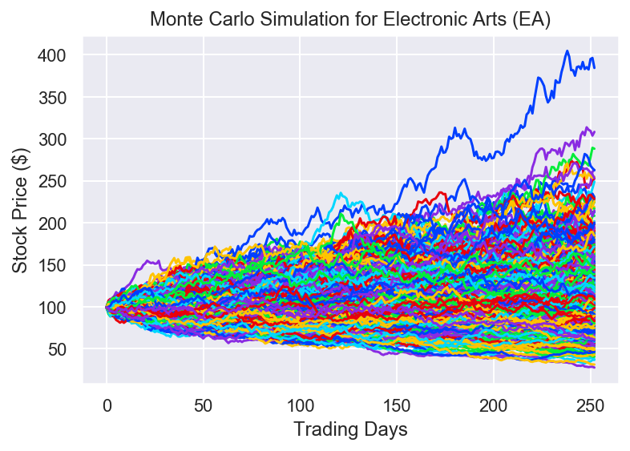

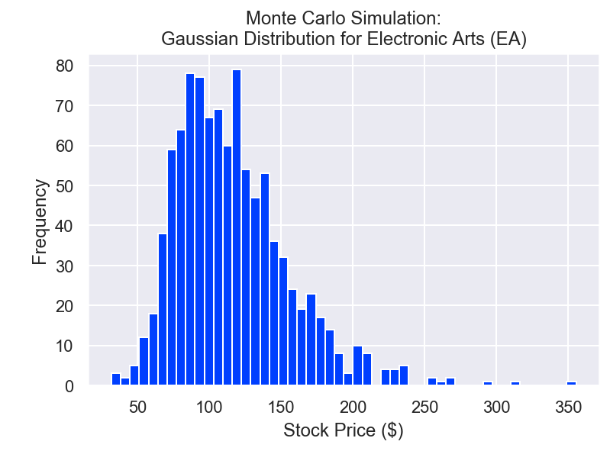

Mean ending value of the simulated 1-year EA stock price: $119.42

EA 95% confidence range: $116.86 - $121.99

Standard deviation: $41.35

The maximum yearly simulated EA return is $398.09

The minimum yearly EA return is $31.00

5th percentile: $65.25

Median: $113.36

95th percentile: $194.04

EA has a mean 1-year return of $119.42, with a standard deviation of $41.35. Relative to ENPH, the mean return is higher and the standard deviation is much lower. The maximum simulated return is also quite a bit lower, at $398.09, but the minimum yearly return is somewhat less egregiously low. The median return, $113.36, is very close to the mean return.

**Monte Carlo: Estee Lauder (EL)**

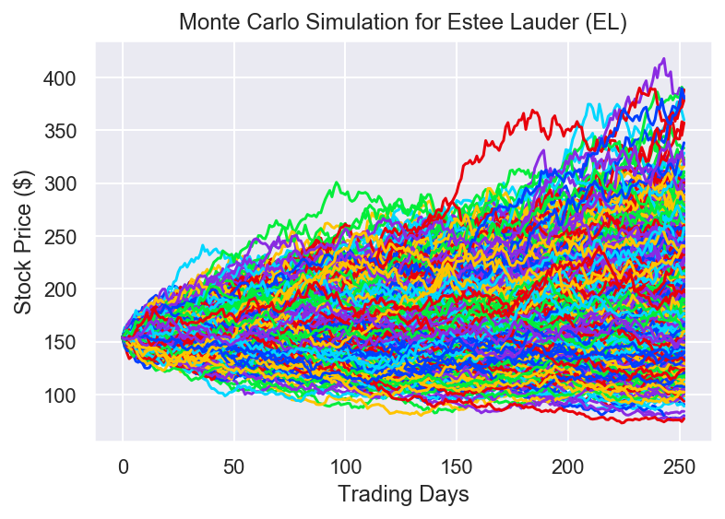

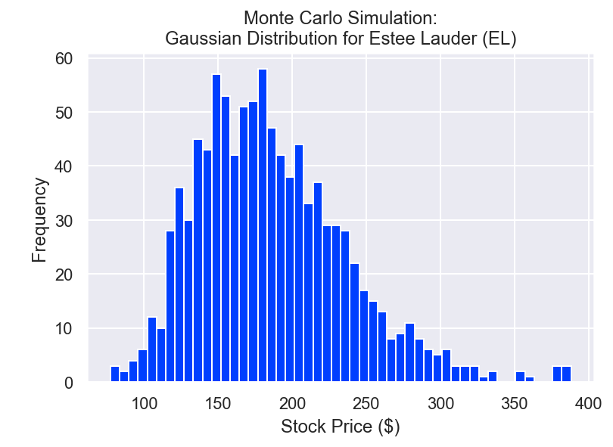

Mean ending value of the simulated 1-year EL stock price: $199.30

EL 95% confidence range: $195.92 - $202.68

Standard deviation: $54.42

The maximum yearly simulated EL stock return is $444.20

The minimum yearly EL return is $76.89

5th percentile: $123.44

Median: $191.17

95th percentile: $298.01

EL’s mean yearly simulated return is $199.30, with a standard deviation of $54.42. Its simulated return is higher than both ENPH and EA, and the standard deviation is right in the middle of those two. The potential maximum return is $444.20, higher than EA’s maximum but significantly lower than ENPH’s; its minimum yearly return, at $76.89, is only slightly lower than ENPH’s mean return, at $75.66. The median is very close to the mean.

1. Perform analysis to optimize portfolio results and present findings.

We used a risk-free-rate of 1.52%, based on the US T-Bill 52 week rate starting 01/02/20.

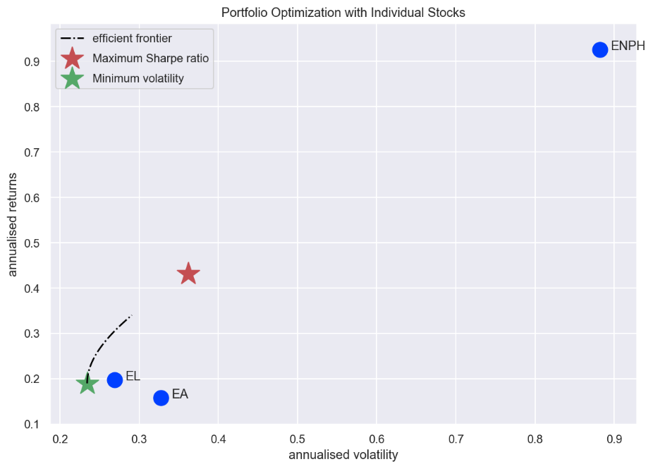

Maximising the Sharpe Ratio, our portfolio breaks down in the following way:

--------------------------------------------------------------------------------

Maximum Sharpe Ratio Portfolio Allocation

Annualised Return: 0.43

Annualised Volatility: 0.36

EA EL ENPH

allocation 13.43 53.75 32.82

--------------------------------------------------------------------------------

Minimum Volatility Portfolio Allocation

Annualised Return: 0.19

Annualised Volatility: 0.23

EA EL ENPH

allocation 36.17 62.88 0.95

--------------------------------------------------------------------------------

Individual Stock Returns and Volatility

EA : annualised return 0.16 , annualised volatility: 0.33

EL : annualised return 0.2 , annualised volatility: 0.27

ENPH : annualised return 0.93 , annualised volatility: 0.88

--------------------------------------------------------------------------------

With this analysis, we recommend breaking down the $1,000,000 investment in the following way:

EA: 13.43%, EL: 53.75%, 32.82%. This split is forecasted to generate an annualized return of 43%. What this means is that we can expect to earn $430,000 from investing 1 million dollars into our portfolio. It is important to also note that our volatility could potentially eat into that great return. But even at it’s most volatile, it would bring our expected annualized return to 7% which is still more than 4 times the risk free rate of investing into US Treasury Bills and so we can confirm that investing into our portfolio is indeed a worthwhile venture as we are able to, at minimum, generate a much greater rate of return than if you had just invested your capital into treasury bills.

# References

(n.d.). Retrieved from https://www.cnbc.com/2018/12/31/stock-market-wall-street-stocks-eye-us-china-trade-talks.html

*Electronic Arts Stock Heads Toward Largest Drop in More Than a Decade After Earnings Miss*. (2019, 02 05). Retrieved from Market Watch: https://www.marketwatch.com/story/electronic-arts-stock-heads-toward-largest-drop-in-more-than-a-decade-after-earnings-miss-2019-02-05

*Electronic Arts stock sales earnings video game apex legends activision take two*. (2019). Retrieved from Barrons: https://www.barrons.com/articles/electronic-arts-stock-sales-earnings-videogame-apex-legends-activision-take-two-51572381659

*Enphase Energy Storage Installations Reach over 18,000 Homes*. (2020, 3 12). Retrieved from Globe NewsWire: https://www.globenewswire.com/news-release/2020/03/12/1999440/0/en/Enphase-Energy-Storage-Installations-Reach-over-18-000-Homes.html

*Enphase installation map*. (n.d.). Retrieved 2 29, 2020, from Enphase: https://enlighten.enphaseenergy.com/public_systems

*Estee Lauder Expands Business Brand Acquisitions*. (2020, 03 12). Retrieved from Market Realist: https://marketrealist.com/2015/08/estee-lauder-expands-business-brand-acquisitions/

*Estee Lauder Millennials*. (2018, 02 02). Retrieved from Fortune: https://fortune.com/2018/02/02/estee-lauder-millennials/

*Stock Market Wall Street Eye US China Trade Talks*. (2018, 12 31). Retrieved from CNBC: https://www.cnbc.com/2018/12/31/stock-market-wall-street-stocks-eye-us-china-trade-talks.htm

*Where wil Enphase Energy be in 5 years?* (2019, 08 01). Retrieved from Fool: https://www.fool.com/investing/2019/08/01/where-will-enphase-energy-be-in-5-years.aspx

*Why Electronic Arts Stock Plunged 25% in 2018*. (2019, 01 10). Retrieved from Fool: https://www.fool.com/investing/2019/01/10/why-electronic-arts-stock-plunged-25-in-2018.aspx

*Why Estee Lauder Shares Surged Today*. (2019, 08 19). Retrieved from Fool: https://www.fool.com/investing/2019/08/19/why-estee-lauder-shares-surged-today.aspx